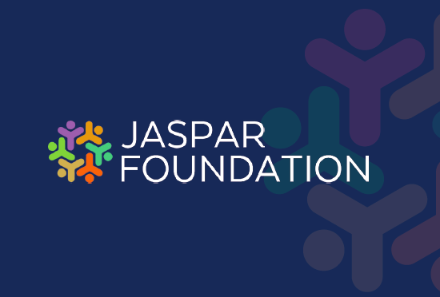
Jaspar Foundation

Application for Funding

Please use this form to apply for grants for your organisation. Additional material can be supplied by email (foundation@jaspargroup.co.uk) or by post to:
Jaspar Foundation, Stanmore House, 16-19 Church Road, Stanmore, Middlesex, HA7 4AR

Section 1 – About your organisation
Name of your organisation:

Postal address:

Phone: Website:

Contact person: Phone:
Email:

Is your organisation a charity? If so, please provide charity number.

If you are not a charity, please state if you are a non-profit organisation, Community Interest Company, social enterprise or have other charitable status.

Details of those in leadership/governance roles within your organisation, e.g. Manager, Directors, Trustees (name and title):

Section 2 – About your project
Is your project in: EDUCATION, HEALTH, LOCAL ORGANISATIONS IN THE HARROW AREA, CHILDREN’S CHARITIES, or OVERSEAS CHARITIES:

Please tell us about your project, including who will benefit from it and how much you are hoping to raise. How did you identify the need for the project? When is the intended start date? The more detail you provide will help us to assess the best way we can support your project. Minimum 100 words - please use separate sheet if necessary

How much are you applying for?

£

Are you applying to other organisations for funding or do you have other funding in place? Yes/No

If so, what proportion of the costs are you hoping the Jaspar Foundation will meet?

How will you measure the benefits of the project to those it is intended to help or support, e.g. number of people expected to use the service and over what period?

How will the project be managed and if successful in your application will you be happy to provide regular progress reports and evaluations to the Jaspar Foundation?

Please email your completed application form plus any supporting material such as previous projects to foundation@jaspargroup.co.uk We aim to acknowledge all applications within 10 working days. For further information call Keith Murray, Manager, on 07870 433 847.

